GUIDELINES FOR STUDENTS
1. Students must come to school in proper uniform.
2. To take any leave, students must submit application in the office. It should be countersigned by parents/guardians.
3. Student must come to school on time.
4. All students will maintain discipline in the class-rooms as well as in school campus.
5. All the students must keep school diary, text books and other Stationeries with them always.

INSTRUCTION FOR GUARDIAN
1. Please check the school diary of your words daily and ensure that instructions are being followed by your ward properly.
2. Provide all necessary requirements to your ward so that they may study well.
3. See and countersign the remarks in the school calendar regularly.
4. Don’t send your ward to the school calendar regularly.
5. Assist your ward in doing home works.
6. Co-operate with the school by depositing the fee by due date.
7. Parents are requested to participate in parents teacher’s meeting.

EXAMINATION & TEST
Two Terminal examinations and four units’ tests will be held throughout the session. Weekly test will be held on every Saturday except last Saturday of the month. Promotion is granted on basis of whole year performance.

GRADES AND REMARKS
Percentage | Grade | Remarks
90% and above | A + | Excellent
70% to 89% | A | Very good
60% to 69% | B | Good
50% to 59% | C | Satisfactory
40% to 49% | D | Pass
Below 40% | E | Failure

Health Check Up
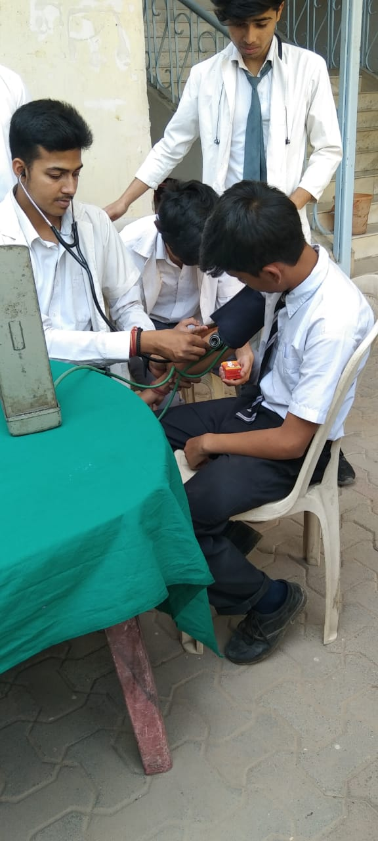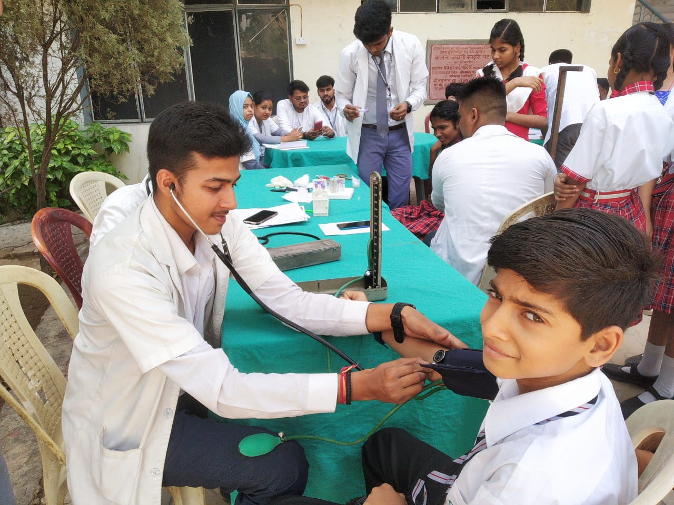
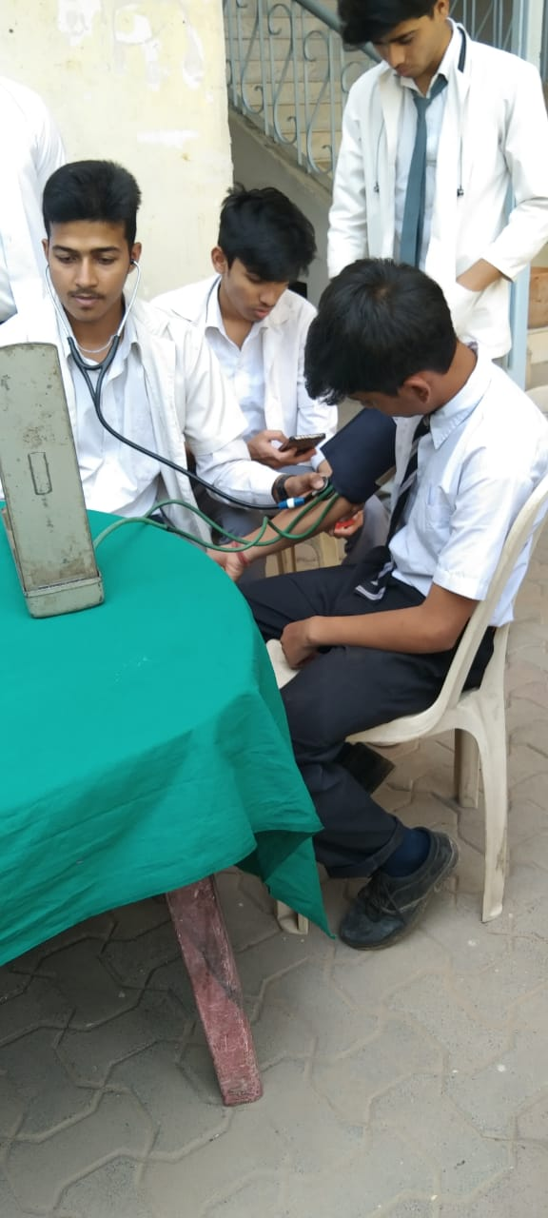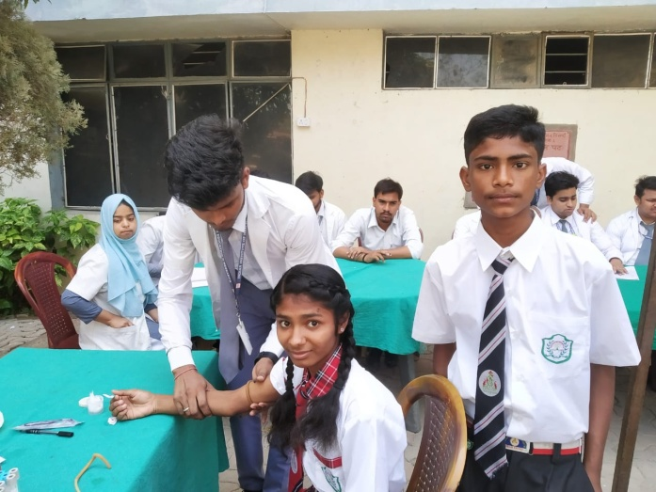
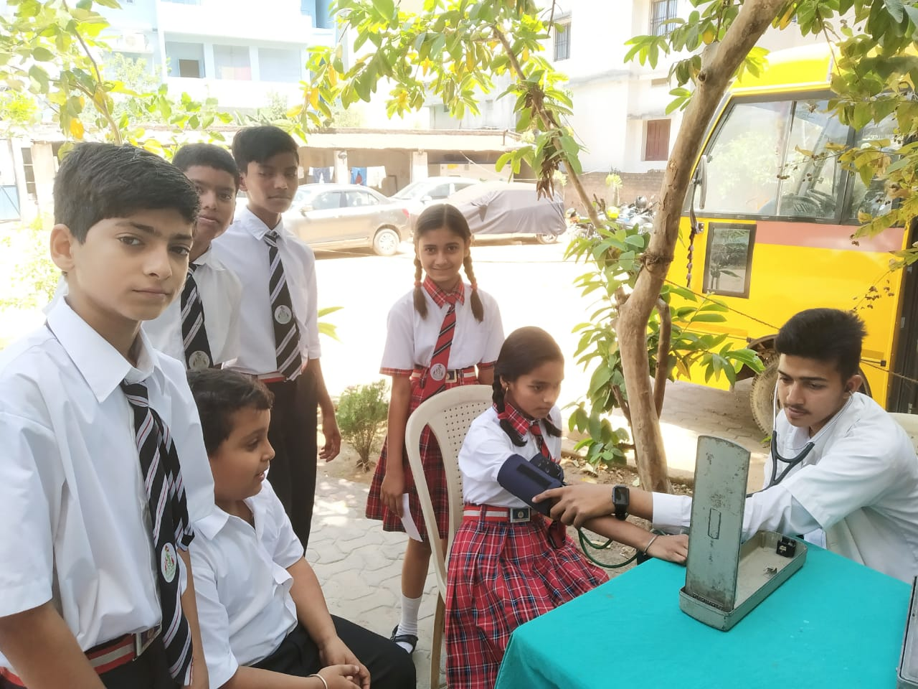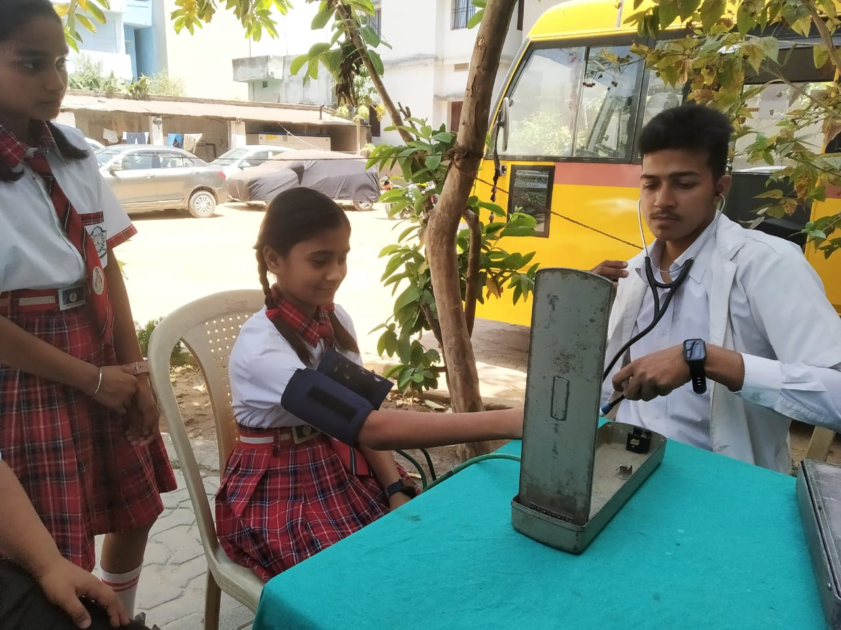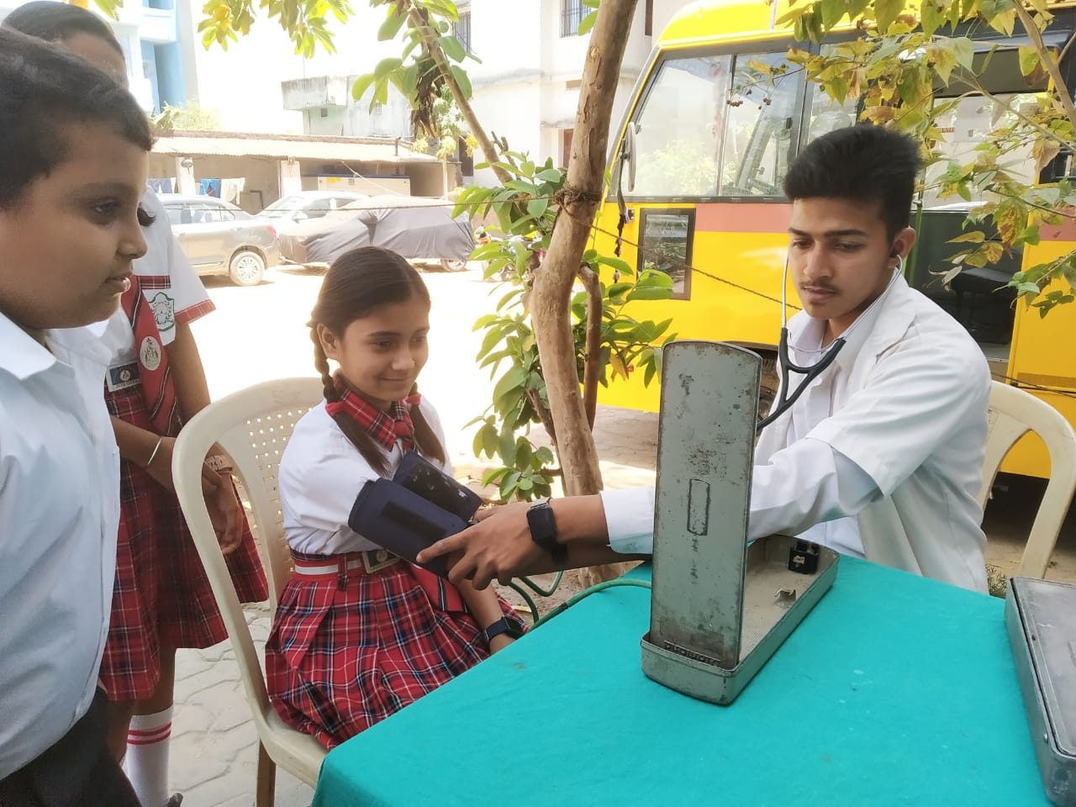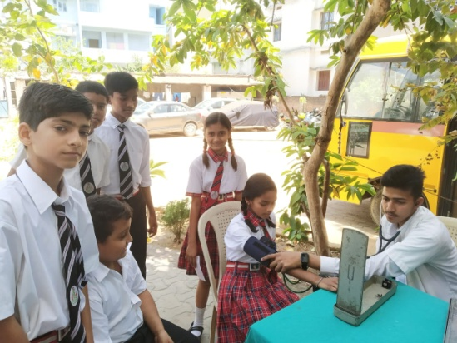
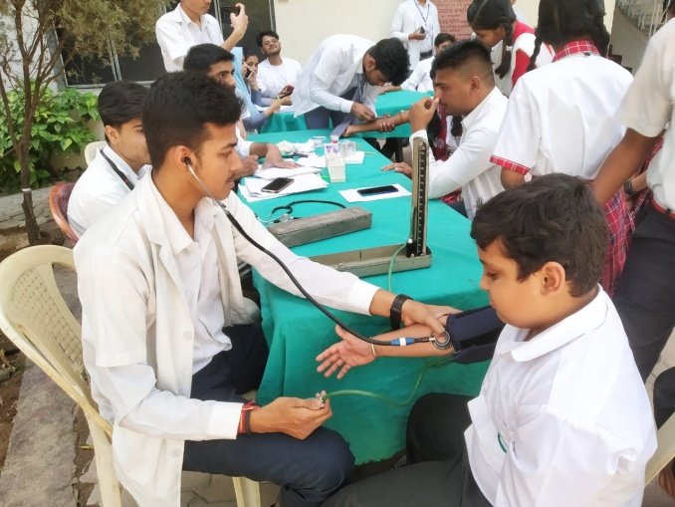
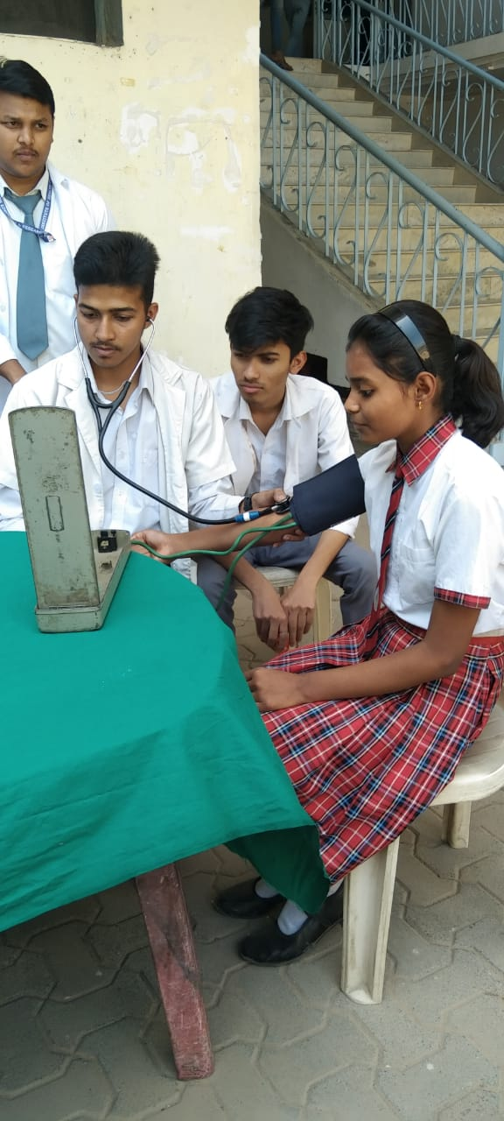

Our Facilities
- Smart/Interactive Class Rooms
- Computer/Science Laboratories.
- Spoken English Classes.Karate Training.
- Art, Dance and Music Classes.
- RO Water Purifier System for students.
- Excursion & Summer Camp
- Indoor and Outdoor Games.
- Play Equipments of KG Classes.
- Parents Teacher Meetings
- Internal Examination Test
- School Canteen
- Health Check Up

